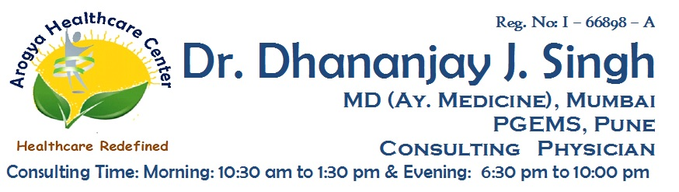

**Reg No: I-83460-A**

**Dr. Akanksha D. Singh**

**MS (PRASUTI TANTRA & STREE ROGA)**

**CONSULTING OBSTETRICIAN & GYNAECOLOGIST**

**Patient’s Name : Gender/Age : F / Date : / /2020**

**K/C/O : HTN / IHD / DM / BA / COPD / KOCHS / RA / NONE**

**HYPO / HYPER THYROIDISM - ON Rx / NOT ON Rx**

**Drug Allergies : NONE /**

**Present Complaints :**

**LMP :**

**M/H :**

**O/H :**

**Rx**

**BP: __________mmHg**

**P : ___________/ min**

**T : ____________F**

**SPO2 : __________%**

**Advice :**

**Follow Up After** : **Dr. Akanksha D. Singh**

**Note :**

1. Please bring this paper on every visit. 3. Don’t substitute any medicine without consultation.
2. This prescription cannot be used for medico-legal purpose. 4. Please confirm medicines with doctor before use.

**Address :** Shop No:3, Rosewood Building, Orchid Residency, Charnipada, Bhiwandi, Dist - Thane